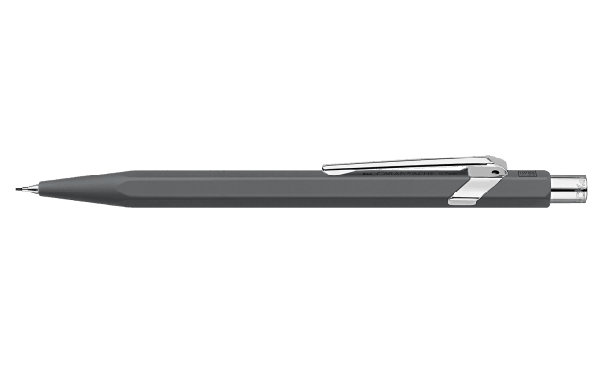

Box of 10 Anthracite Grey 849™ CLASSIC LINE Mechanical Pencil

Constantly revealing new facets of its personality, the legendary 849™ pen is available as an attractive and handy mechanical pencil – the 849™. This lightweight instrument is highly resistant and offers optimum holding comfort.